 | COLÉGIO PEDRO II - CAMPUS SÃO CRISTÓVÃO III  1ª SÉRIE – MATEMÁTICA II  NOME:

REFORÇO 6 – MAT II – LEI DOS COSSENOS - GABARITO

1) Um triângulo ABC tem lados AB e BC que medem, respectivamente, 6 cm e 8 cm. Determine a medida do lado AC, sabendo que o ângulo B mede 120º.
GABARITO:
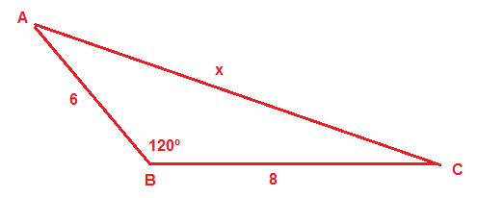
$$\begin{aligned}\text{Pela} \text{Lei} \text{dos} \text{Cossenos}, \text{temos}: \\ x²=6²+8²−2\text{.}6\text{.}8\text{.}\text{cos}\text{120}º→x²=\text{36}+\text{64}−\text{96}\text{.}(−1/2) \\ →x²=\text{100}+\text{48}→x²=\text{148}→x=\sqrt{\text{148}}→x=2\sqrt{\text{37}}\end{aligned}$$

2) Um triângulo ABC tem lados AB e BC que medem, respectivamente, 5 cm e 7 cm. Determine a medida do lado AC, sabendo que o ângulo B mede 60º.

GABARITO:

$$\begin{aligned}O \text{lado} \text{AC} \text{está} \text{oposto} \text{ao} \text{ângulo} B\text{.} \text{Aplicando} a \text{Lei} \text{dos} \text{Cossenos}, \text{temos}: \\ \overline{\text{AC}}²=5^{2}+7²−2\text{.}\left(5\right)\text{.}(7)\text{.}\text{cos}\text{60}º⇒\overline{\text{AC}}²=\text{25}+\text{49}−\text{70}\text{.}\left(\frac{1}{2}\right) \\ \overline{\text{AC}}²=\text{25}+\text{49}−\text{35}⇒\overline{\text{AC}}²=\text{109}⇒\overline{\text{AC}}=\sqrt{\text{39}} \text{cm}\end{aligned}$$

3) Na figura abaixo, encontre o valor de x.
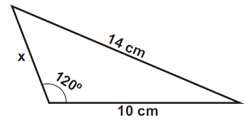

GABARITO:
$$\begin{aligned}\text{Pela} \text{Lei} \text{dos} \text{cos}\text{senos}, \text{temos}: \\ \text{14}²=\text{10}²+x²−2\text{.}x\text{.}\text{10}\text{.}\text{cos}\text{120}º→\text{196}=\text{100}+x²−\text{20}x\text{.}(−1/2)→\text{96}=x²+\text{10}x→x²+\text{10}x−\text{96}=0 \\ x=\frac{−\text{10}±\sqrt{\text{10}²−4\text{.}1\text{.}(−\text{96})}}{2\text{.}1}→x=\frac{−\text{10}±\sqrt{\text{484}}}{2}→x=\frac{−\text{10}±\text{22}}{2}→x_{1}=−\text{16} e x_{2}=6\text{.}\text{Logo}, x=6\text{.}\end{aligned}$$
4) Um triângulo ABC tem lados AB, AC e BC que medem, respectivamente, 5 cm, 10 cm e 9 cm. Determine a medida da mediana relativa ao lado AC.

GABARITO:

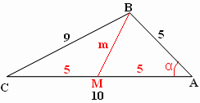

$$\begin{aligned}\text{Mediana} é o \text{segmento} \text{que} \text{parte} \text{de} \text{um} \text{vértice} \text{do} \text{triângulo} e \text{divide} o \text{lado} \text{oposto} \text{em} \text{partes} \text{iguais}, \\ \text{conforme} \text{figura} \text{acima}\text{.} \text{Aplicando} a \text{Lei} \text{dos} \text{Cossenos}, \text{temos}: \\ i) 9²=5^{2}+\text{10}²−2\text{.}\left(5\right)\text{.}(\text{10})\text{.}\text{cos}α⇒\text{cos}α=\frac{\text{81}−\text{125}}{−\text{100}}=\frac{\text{44}}{\text{100}}=\frac{\text{11}}{\text{25}} \\ \text{ii}) m²=5^{2}+5²−2\text{.}\left(5\right)\text{.}(5)\text{.}\text{cos}α⇒m²=\text{50}−\text{50}\text{.}\left(\frac{\text{11}}{\text{25}}\right)⇒ \\ ⇒m=\sqrt{\text{50}−\text{22}}=\sqrt{\text{28}}=2\sqrt{7} \text{cm}\end{aligned}$$

5) Dado um triângulo de lados 5 cm, 7 cm e 8 cm, determine o valor do seno do maior ângulo interno desse triângulo.

GABARITO:
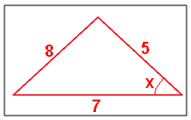

$$\begin{aligned}O \text{maior} \text{lado} \text{está} \text{oposto} \text{ao} \text{maior} \text{ângulo}\text{.} \text{Assim}, \text{pela} \text{Lei} \text{dos} \text{Cossenos}, \text{temos}: \\ 8²=5²+7²−2\text{.}5\text{.}7\text{.}\text{cos}x→\text{64}=\text{25}+\text{49}−\text{70}\text{.}\text{cos}x→\text{64}=\text{74}−\text{70}\text{.}\text{cos}x \\ \text{70}\text{.}\text{cos}x=\text{10}→\text{cos}x=\frac{1}{7}\text{.} \text{Mas}, \text{sen}²x+\text{cos²}x=1→\text{sen}²x+(\frac{1}{7})^{2}=1 \\ \text{sen}²x+\frac{1}{\text{49}}=1→\text{sen}²x=1−\frac{1}{\text{49}}→\text{sen}²x=\frac{\text{48}}{\text{49}}→\text{senx}=\frac{\sqrt{\text{48}}}{\text{49}}→\text{senx}=\frac{4\text{.}\sqrt{3}}{7}\end{aligned}$$

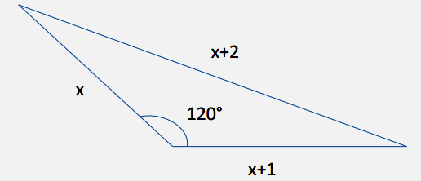
6) Calcule x no triângulo abaixo.

GABARITO:

$$\begin{aligned}\text{Pela} \text{Lei} \text{dos} \text{Cossenos}, \text{temos}: \\ (x+2)²=x²+(x+1)²−2\text{.}x\text{.}(x+1)\text{.}\text{cos}\text{120}º→x²+4x+4=x²+x²+2x+1−2\text{.}x\text{.}(x+1)\text{.}(−1/2) \\ 4x+4=x²+2x+1+x\text{.}(x+1)→2x+3=x²+x²+x→2\text{.}x²−x−3=0→x=\frac{−(−1)±\sqrt{(−1)²−4\text{.}2\text{.}(−3)}}{2\text{.}2} \\ x=\frac{1±\sqrt{\text{25}}}{4}→x=\frac{1±5}{4}→x_{1}=−1 e x_{2}=\frac{6}{4}=1,5\text{.} \\ \text{Logo}, x=1,5\text{.}\end{aligned}$$

