 | COLÉGIO PEDRO II - CAMPUS SÃO CRISTÓVÃO III  1ª SÉRIE – MATEMÁTICA I  NOME:

REFORÇO 5 – MAT I – DÍZIMAS PERIÓDICAS E INTERVALOS REAIS - GABARITO

1) Obtenha as frações geratrizes das seguintes dízimas periódicas:
a) 0,222... b) 2,777... c) 8,101010... d) 5,1666... e) $1,\text{23 \{}\bar{3}$
GABARITO:
a) $\begin{aligned}\left\{x=0,\text{222}\text{.}\text{.}\text{.} | \right.\end{aligned}$.
b) $\begin{aligned}\left\{x=2,\text{777}\text{.}\text{.}\text{.} | \right.\end{aligned}$.
c) $\begin{aligned}\left\{x=8,\text{101010}\text{.}\text{.}\text{.} | \right.\end{aligned}$.
d) $\begin{aligned}\left\{x=5,\text{1666}\text{.}\text{.}\text{.} | \right.\left\{\text{10}x=\text{51},\text{666}\text{.}\text{.}\text{.}← | \right.\end{aligned}$.
e) $\begin{aligned}\left\{x=1,\text{23 \{}\bar{3} | | 1,\text{233}\text{.}\text{.}\text{.} | \right.\left\{\text{10}x=\text{12},\text{33}\text{.}\text{.}\text{.}← | \right.\end{aligned}$.

2) Resolva: $\frac{8^{\frac{1}{3}}×0,\text{333}\text{.}\text{.}\text{.}−(\text{30})^{−1}}{3^{\frac{1}{2}}×3^{\frac{1,5}{3}}−\frac{1}{\text{15}}}$
GABARITO:
$\begin{aligned}\frac{8^{\frac{1}{3}}×0,\text{333}\text{.}\text{.}\text{.}−(\text{30})^{−1}}{3^{\frac{1}{2}}×3^{\frac{1,5}{3}}−\frac{1}{\text{15}}}=\frac{\sqrt[3]{8}×\frac{1}{3}−\frac{1}{\text{30}}}{\sqrt{3}×3^{0,5}−\frac{1}{\text{15}}}=\frac{2×\frac{1}{3}−\frac{1}{\text{30}}}{\sqrt{3}×3^{\frac{1}{2}}−\frac{1}{\text{15}}}=\frac{\frac{2}{3}−\frac{1}{\text{30}}}{\sqrt{3}×\sqrt{3}−\frac{1}{\text{15}}}=\frac{\frac{\text{20}−1}{\text{30}}}{3−\frac{1}{\text{15}}}= \\ \frac{\frac{\text{19}}{\text{30}}}{\frac{\text{45}−1}{\text{15}}}=\frac{\frac{\text{19}}{\text{30}}}{\frac{\text{44}}{\text{15}}}=\frac{\text{19}}{\text{30}}\text{.}\frac{\text{15}}{\text{44}}=\frac{\text{19}}{2}\text{.}\frac{1}{\text{44}}=\frac{\text{19}}{\text{88}}\end{aligned}$

3) Represente, na reta real, os intervalos:

a) [2, 8]
b) [– 6, – 1[
c) {x є IR / 2 < x < 5}
d) c) {x є IR / 3 < x ≤ 7}
e) [0, +∞[
f) {x є IR / x ≥ – 1}
g) {x є IR / – 2 ≤ x ≤ 2}
GABARITO:

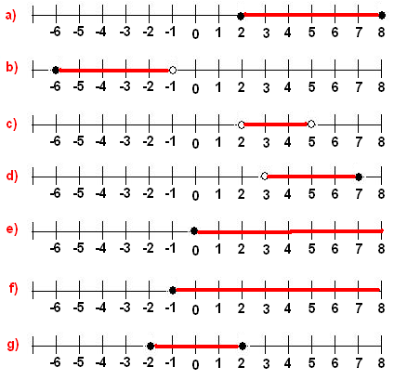
4) Dados os conjuntos $A=[−4,6[$ ; $B=[−5,5]$ e $C=]−6,2[$; determine, utilizando a notação de intervalos e a representação na reta real:
A) $A∩B$
B) $(A∪B)$
C) $(A∪B)−C$

GABARITO:

A) $A∩B$= [– 4, 5].
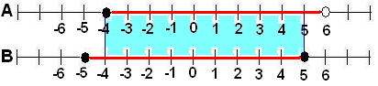

B) $(A∪B)$= [– 5, 6[.
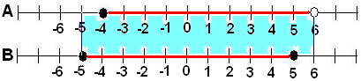

C) $(A∪B)−C$ = [2, 6[.
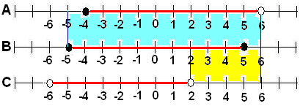

5) Dados os conjuntos $A=[−7,6[$; $B=[−5,7]$ e $C=]−2,2]$; determine, utilizando a notação de intervalos e a representação na reta real:
A) $A∩B$
B) $(A∪B)−C$

GABARITO:

A) $A∩B$ = [– 5, 6[.
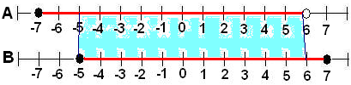

B) $(A∪B)−C$ = [– 7, – 2] ∪ ]2, 7].
